Experiment No 3
- Title: Implement control structures and form validation; create a grading system based on user-entered marks.
2. Software/Tools Required:
- Visual Studio Code (VS Code)
- Google Chrome
- HTML5
- JavaScript
3. Theory:
• Control Structures: Statements like if-else or switch-case that control the execution flow of a program based on specified conditions.
• Form Validation: The process of ensuring user input is valid, non-empty, and within acceptable limits before processing.
• Gading Criteria:
- 90 – 100: Grade A+
- 80 – 89: Grade A
- 70 – 79: Grade B
- 60 – 69: Grade C
- 50 – 59: Grade D
- 0 – 49: Grade F

4. Output:
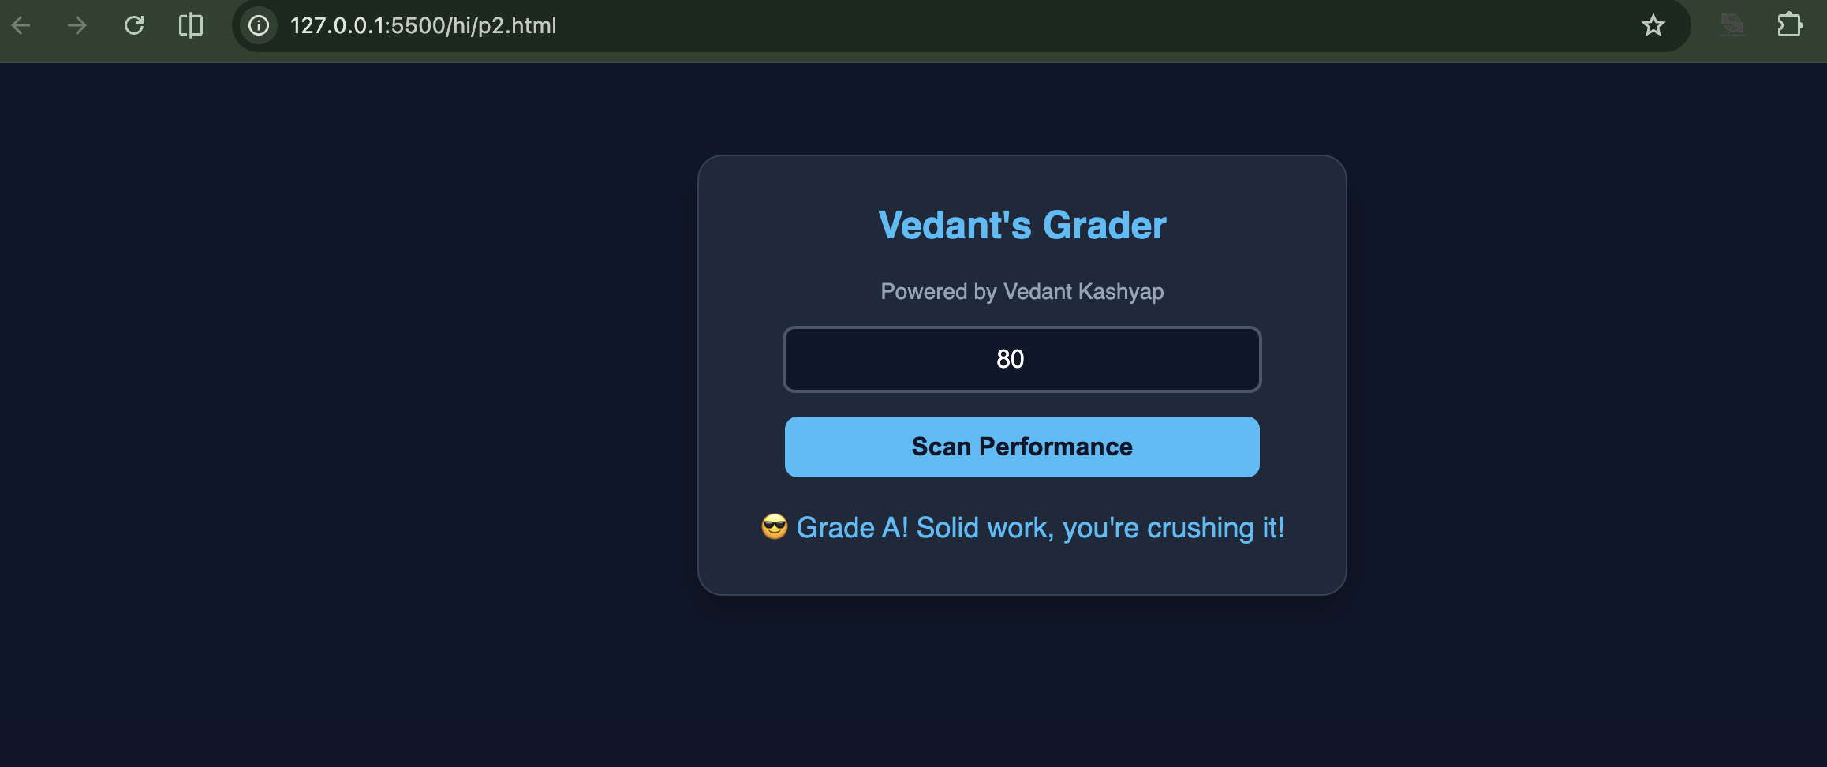

5. Result/Conclusion:
In this practical, form validation and conditional control structures (if-else) were successfully implemented. The system effectively restricts input values to a valid range of 0 to 100, prevents empty submissions, and accurately computes student grades based on the entered marks.

